**PHASES OF SDLC:-**

There are Main 7 phases of Software development Lifecycle:-

1. PLANNING & REQUIREMENT ANALYSIS
2. FEASIBLITY STUDY/DEFINING
3. DESIGNING
4. CODING
5. TESTING
6. DEPLOYEMENT
7. MAINTENANCE

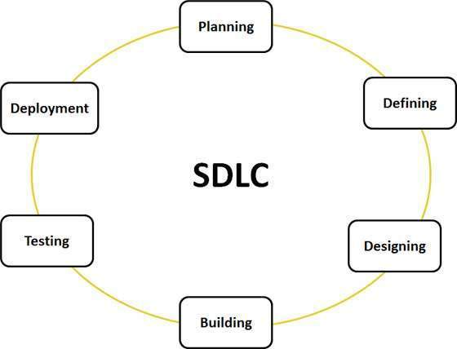

[This Photo](https://kenscourses.com/tc1019fall2016/syndicated/sdlc/) by Unknown Author is licensed under [CC BY-SA](https://creativecommons.org/licenses/by-sa/3.0/)

1. **PLANNING & REQUIREMENT ANALYSIS**

* Under this phase all the necessary information is gathered here
* Collecting the Client Requirement
* Setting goals and objective
* Resource planning
* Converting business language into Software Requirement specification (SRS)

1. **FEASIBLITY STUDY / DEFINING**

* Functional requirement
* Finance requirement
* Architectural planning
* Technical requirement

1. **DESIGNING**

* **High level design**
* In this overall description of design is given like System design, Database Planning

And a Brief overview of Frontend technology ,Backend Technology is given here.

* **Low Level Design**
* In this Detailed description of all the component is given.

1. **Coding**

* Here all the development part is done from presentation layer to Business logic layer and Database connectivity.

1. **Testing**

* There are 2 ways of testing the software
* Manual testing
* Automate Testing

1. **Deployment**

* After the development the project is deployed on the Read world Environment
* DEPLOMENT ENVIRONMENT- all the developer Pushes in development environment after the development is done
* TEST ENVIRONMENT- Tester test all the feature , if it is working properly then it is pushed into Production environment else again pushed into the development environment.
* PRODUCTION ENVIRONMENT – here the project is released after all the development into real world .

1. **Maintenance**

* It is service after the deployment of the application.
* To handle any problem
* It makes the application more reliable because there is always a team working to maintain the application.

**CONCLUSION:**

**In software development lifecycle every phase is important and every phase is linked with one another.**

**If a client want customer to built an application then , we have to follow all the phases of SDLC because with that only we will be able to built a robust and high quality application**